**Problem 2:**

1. Suppose you have a file named "data.txt" containing important information. Display the first 10 lines of this file to quickly glance at its contents using a command.

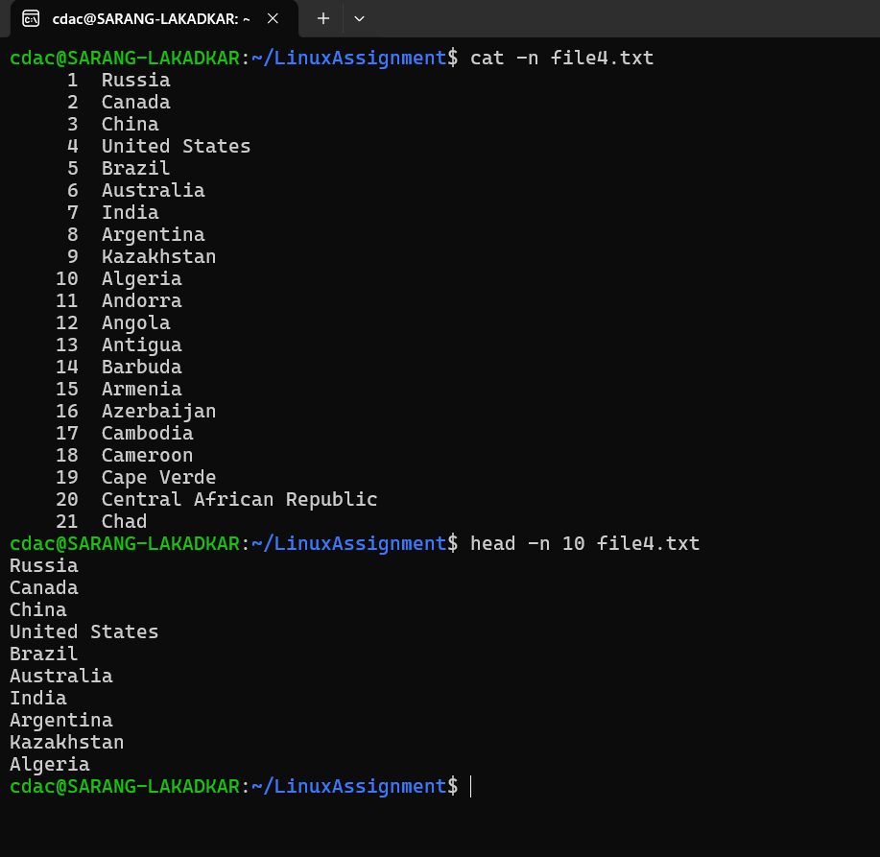

1. Now, to check the end of the file for any recent additions, display the last 5 lines of

"data.txt" using another command

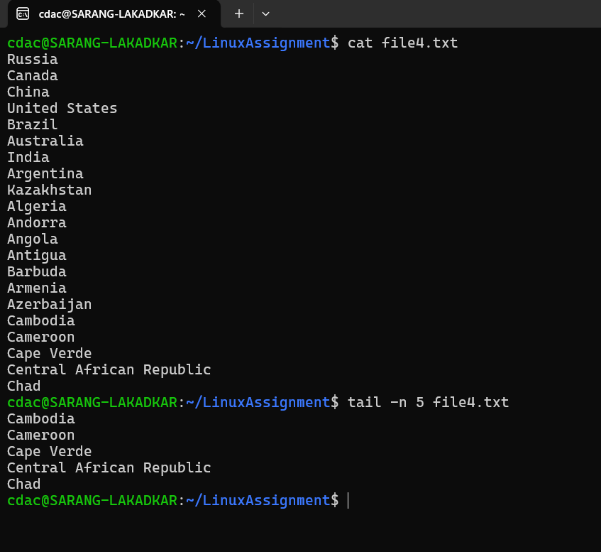

1. In a file named "numbers.txt," there are a series of numbers. Display the first 15 lines of this file to analyze the initial data set

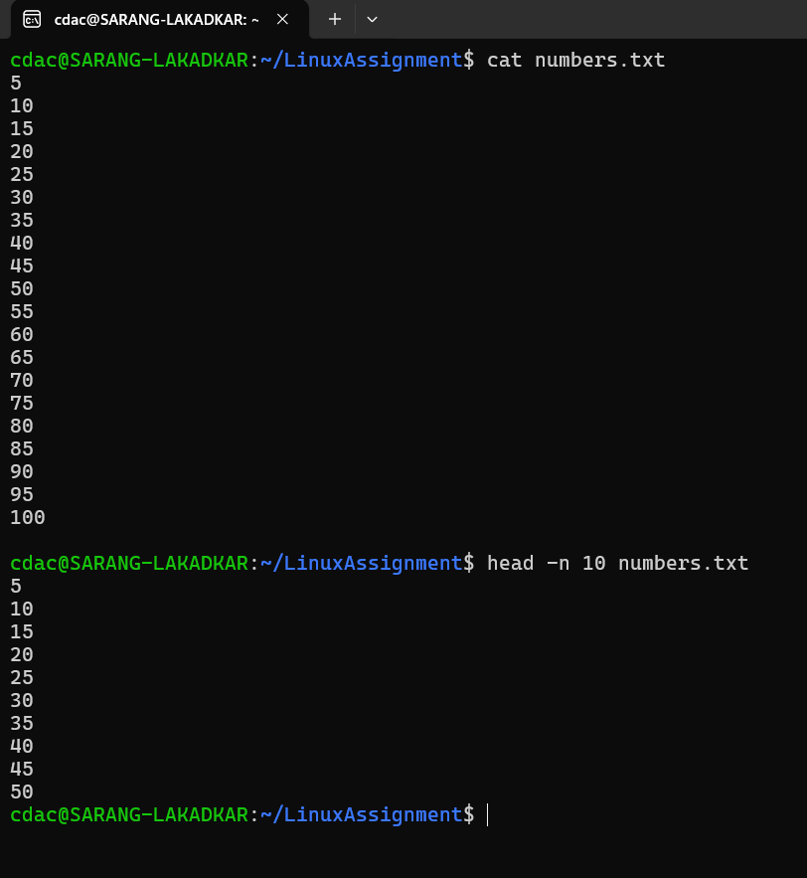

1. To focus on the last few numbers of the dataset, display the last 3 lines of "numbers.txt".

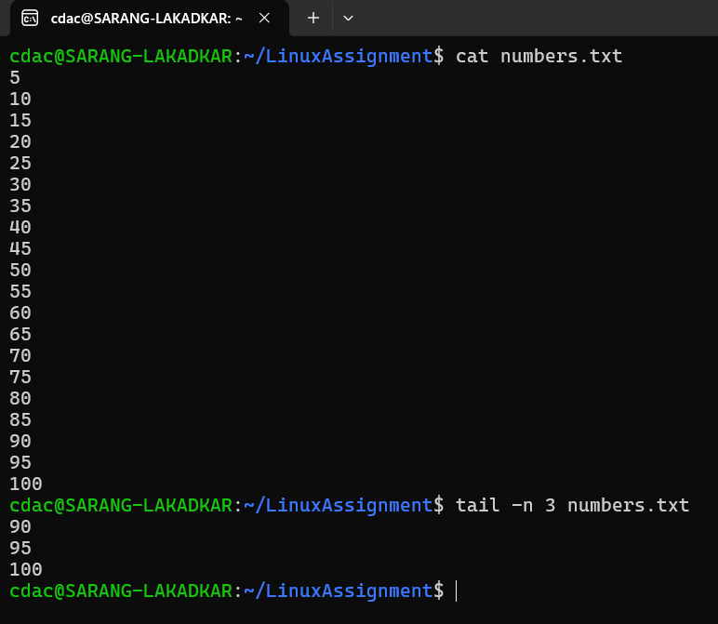

1. Imagine you have a file named "input.txt" with text content. Use a command to translate all lowercase letters to uppercase in "input.txt" and save the modified text in a new file named "output.txt.

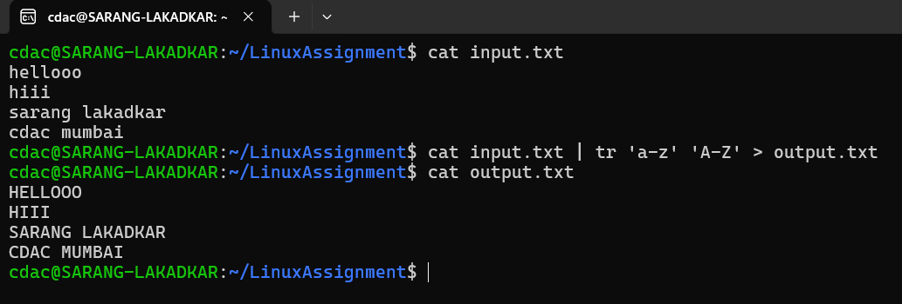

1. In a file named "duplicate.txt," there are several lines of text, some of which are duplicates. Use a command to display only the unique lines from "duplicate.txt."

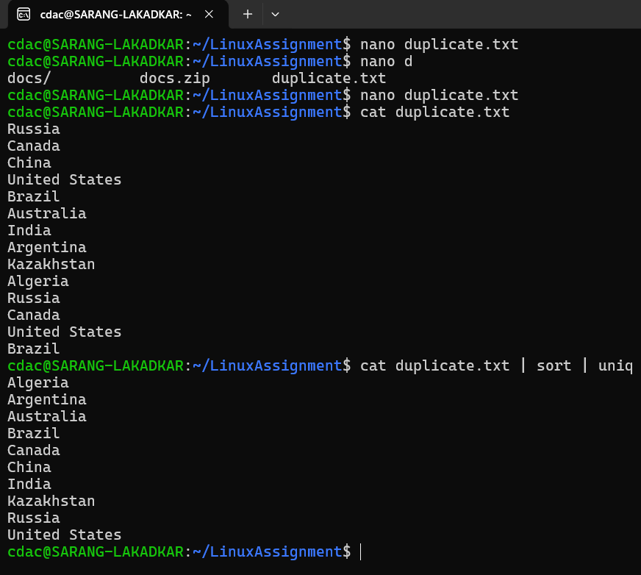

1. In a file named "fruit.txt," there is a list of fruits, but some fruits are repeated. Use a command to display each unique fruit along with the count of its occurrences in "fruit.txt.”

